Project Planning Phase
Project Planning Template (Product Backlog, Sprint Planning, Stories, Story points)
Date | 04 October 2026
Team ID | SWTID-2026-6870
Project Name | Streamlining IT Procurement: Automating Standard Laptop Orders with Flow Designer
Maximum Marks | 5 Marks

Product Backlog, Sprint Schedule, and Estimation
Story points follow the Fibonacci-style scale used in the planning guide: 1 = very easy, 2 = normal, 3 = moderate, 5 = difficult. The project was split into 2 sprints.
Sprint | Functional Requirement (Epic) | User Story No. | User Story / Task | Story Points | Priority | Team Members
Sprint-1 | Flow creation | USN-1 | As a flow developer, I can create the flow "Standard laptop task" (Global, Run As System User). | 2 | High | [Add name]
Sprint-1 |  | USN-2 | As a flow developer, I can add the Service Catalog trigger. | 1 | High | [Add name]
Sprint-1 |  | USN-3 | As a flow developer, I can add the Create Catalog Task action with short description, description, Assignment group Hardware and Approval Approved. | 3 | High | [Add name]
Sprint-1 |  | USN-4 | As a flow developer, I can save and activate the flow. | 1 | High | [Add name]
Sprint-1 | Flow assignment | USN-5 | As a catalog administrator, I can attach the flow to the Standard Laptop item under Process Engine. | 2 | High | [Add name]
Sprint-2 | Ordering & approval | USN-6 | As an employee, I can order a Standard Laptop from Service Catalog > Hardware. | 2 | High | [Add name]
Sprint-2 |  | USN-7 | As an approver, I can approve the request from the Approvers related list. | 2 | High | [Add name]
Sprint-2 | Task verification | USN-8 | As a Hardware team member, I can see the catalog task assigned to my group under the Requested Item. | 3 | High | [Add name]
Sprint-2 | Testing & documentation | USN-9 | As the project team, we can run functional tests and UAT. | 3 | Medium | [Add name]
Sprint-2 |  | USN-10 | As the project team, we can document the project and results. | 2 | Medium | [Add name]
Sprint-1 total = 2+1+3+1+2 = 9 story points. Sprint-2 total = 2+2+3+3+2 = 12 story points. Total = 21 story points.

Project Tracker, Velocity & Burndown Chart
Sprint | Total Story Points | Duration | Sprint Start Date | Sprint End Date (Planned) | Story Points Completed (as on Planned End Date) | Sprint Release Date (Actual) | Velocity (points/day)
Sprint-1 | 9 | 7 Days | 21 Sep 2026 | 27 Sep 2026 | 9 | 27 Sep 2026 | 1.29
Sprint-2 | 12 | 7 Days | 28 Sep 2026 | 04 Oct 2026 | 12 | 04 Oct 2026 | 1.71

Velocity
Average velocity = Total story points completed ÷ number of sprints = (9 + 12) ÷ 2 = 10.5 story points per sprint. Per day, velocity = 21 ÷ 14 days = 1.5 story points per day.

Burndown Chart
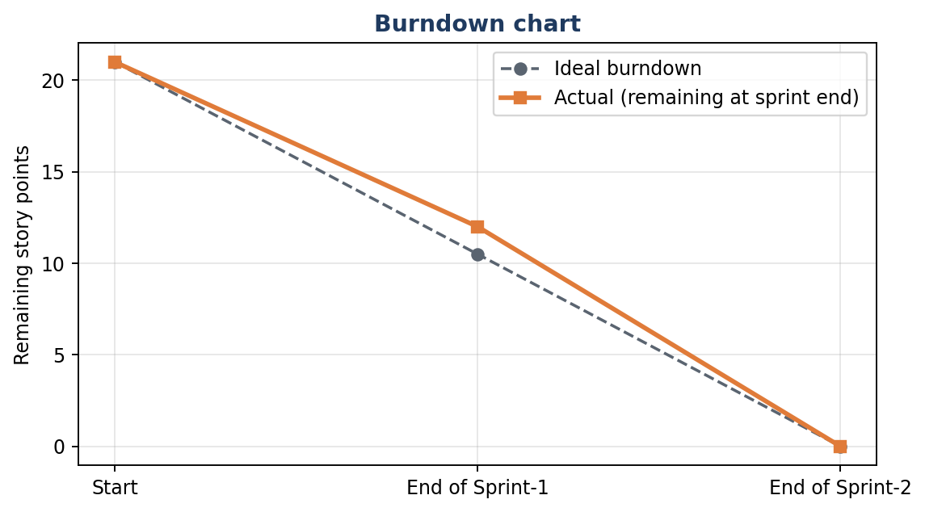
Figure 1: Burndown chart (remaining story points at sprint end)
Sprint dates in this document are planning dates and can be changed to match your actual schedule.

